**Formative assessment in Reading and Listening:**

The formative assessment is the process to improve students’ knowledge of English and allow them to think and analyze during learning.

The following strategies of formative assessment help the teachers to make the process of assessment memorable, useful and students will be able to think, participate, analyze, argue, share the ideas.

**Strategy “Clapping”.**

When the students read the information, the texts, the dialogues the other students listen to the information and clap their hands if they listen to the mistake. The student stops and corrects the mistake, then continues reading. This strategy is excellent for “Good reading”, if the student has got 1 mistake minus 1 point, this is 4, no mistakes is 5, 2 mistakes is 3, 3 mistakes is try again.

**Strategy “Green and Red”.**

When the students listen to the mistake they show a red colour card, the other student has to correct the mistake and then continues reading.

**Strategy “Green and Red”**

for listening. Students listen to the information and if they don’t agree with the statement they show a red card, but if they would like to add the information or they agree, they show a green card.

**Strategy “Knock at the desk”.**

Students listen to the other student and knock at the desk when they listen to the mistake.

В своем сборнике мы предлагаем примеры критериального оценивания

презентаций и групповых работ учащихся по разным темам.

**Assessment according to the criterias:**

**Criterias of the presentation on the paper:**

1. Write the name of your group. - 1 point

2. Find 5 horrible facts about George’s holiday in your part, write them.- 5 points, one point for each right answer.

3. Change I to he or George, my to his! - 1 point

4. Draw a picture! – 2 points

5. The design of the presentation – 1 point

Total: 10 points maximum

1 point may be divided into 0,9- 0,1

Другой пример критериального оценивания

Group work, the presentation about wingsuit flying, white water rafting, playing wii

**The criterias of assessment : Vocabulary “Sports”**

The presentation is 12 sentences**-1 point**

Describe the picture p.30 -**1 point**

Essential information from Interrnet-**1 point**

Right grammar and IELTS vocabulary -**1 point**

Design of the poster-**1 point**

Compare with our country-**1 point**

**(Maximum 6 points)**

**Speaking Assessment**

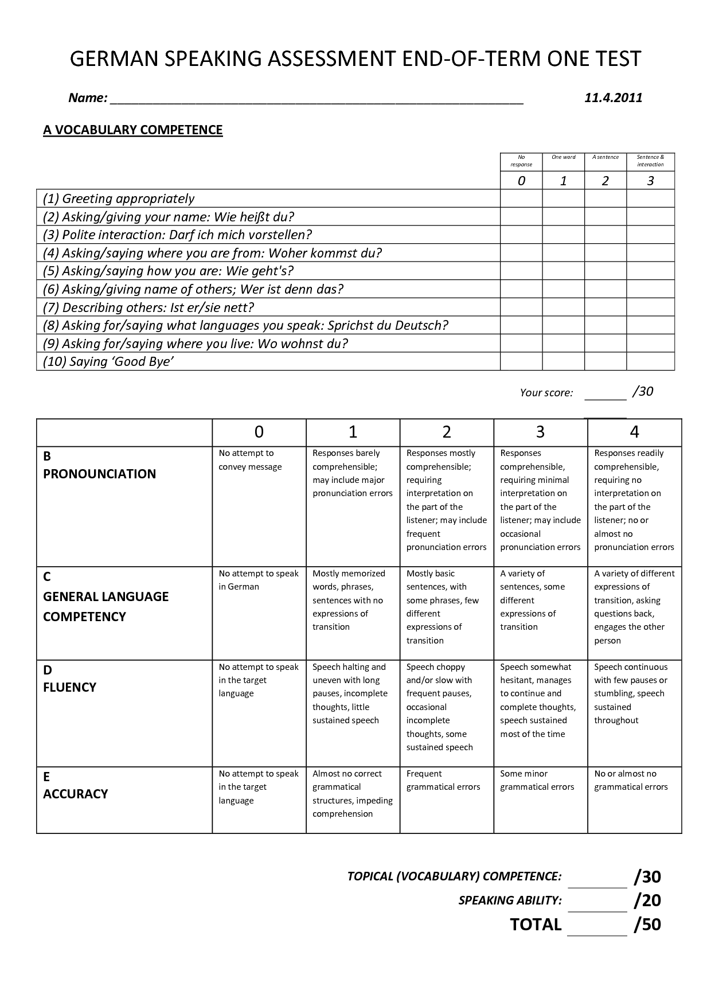

**Decision Making Chart**

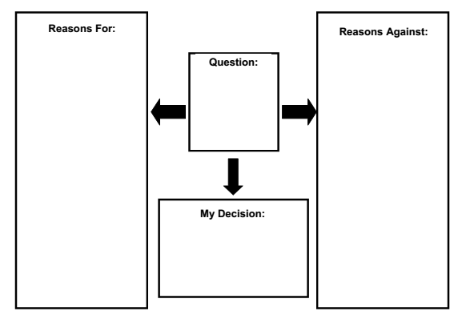

**Speaking Assessment Criteria**

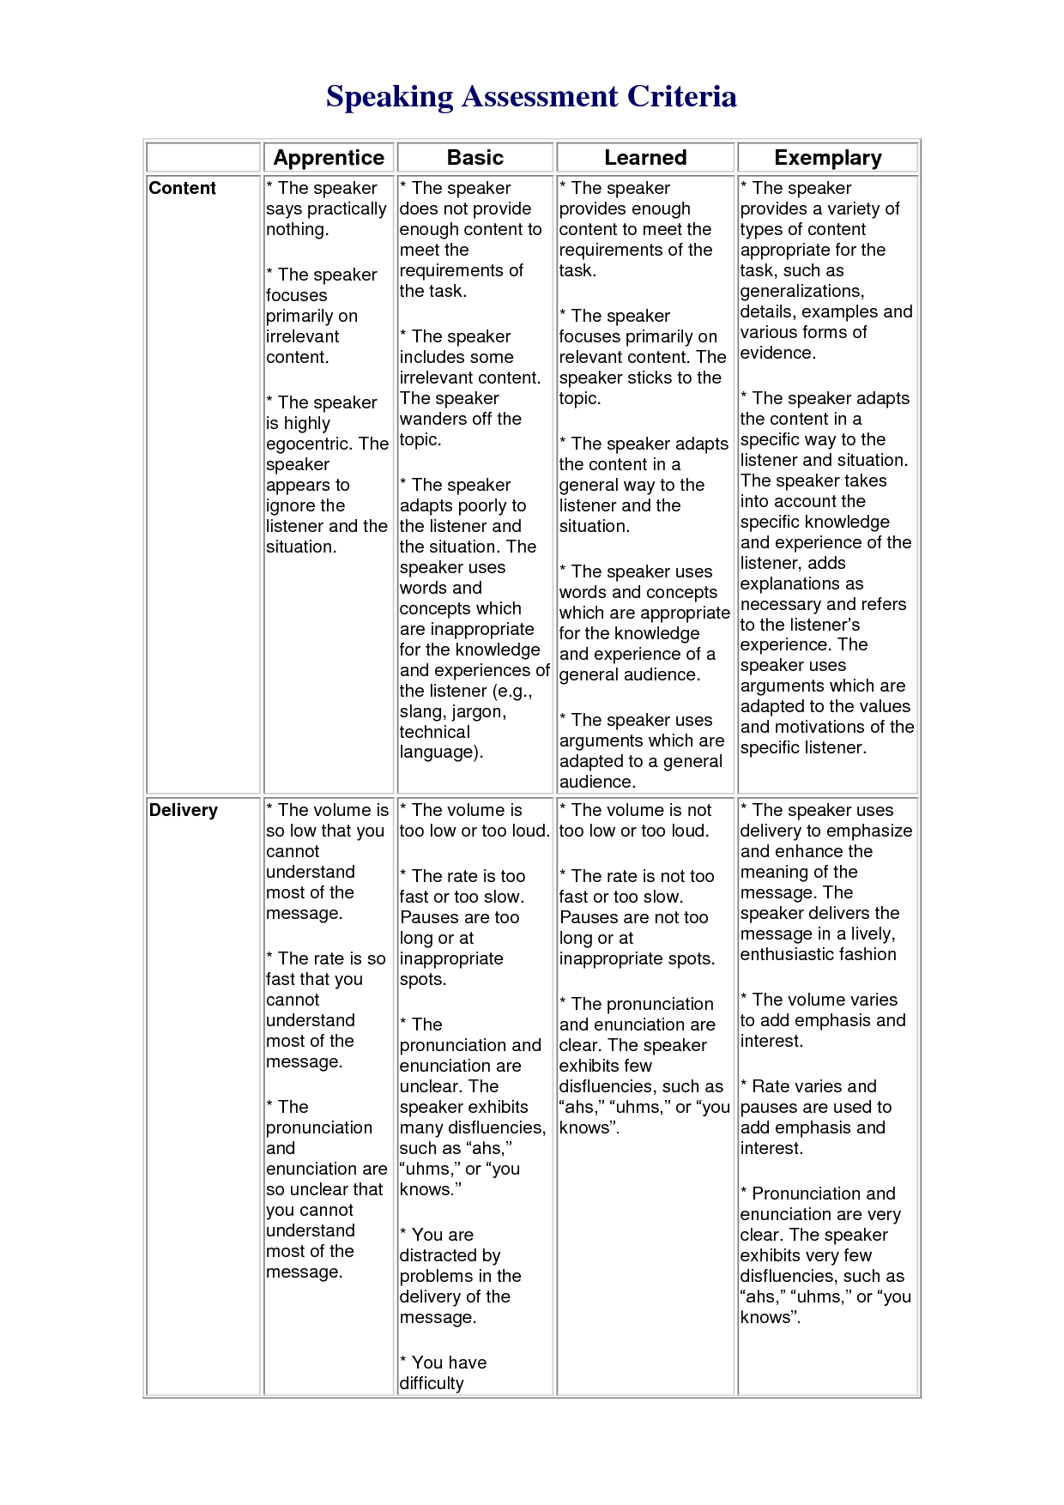

**Self-Assessment Rubric**

Focus: The student uses oral and visual strategies to communicate. The student uses oral language for different purposes: to inform, persuade, or entertain.

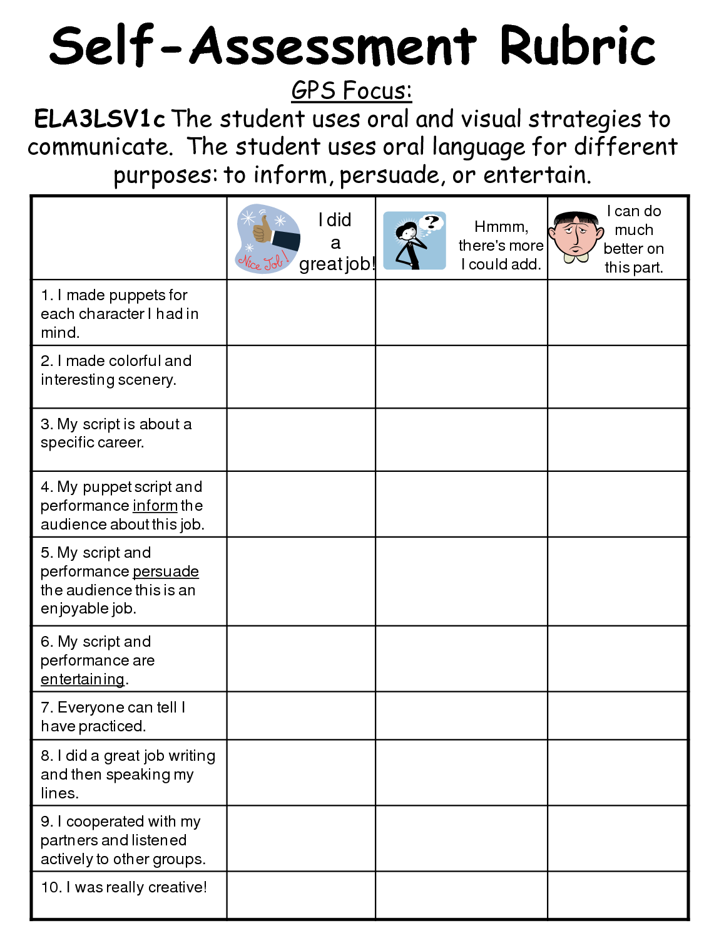

**Writing Rubric: Capitalization**

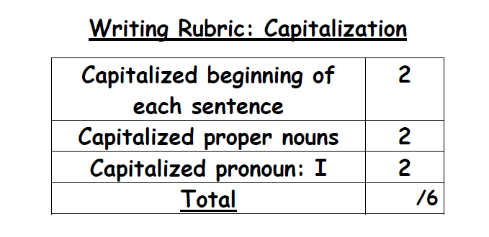

**Dialogue Rubric**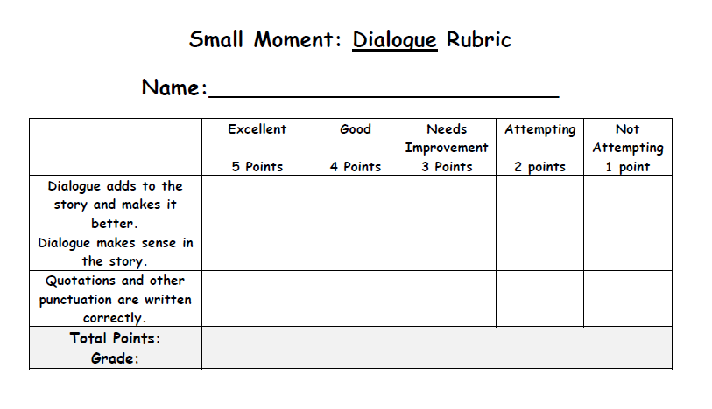

**Ending Rubric**

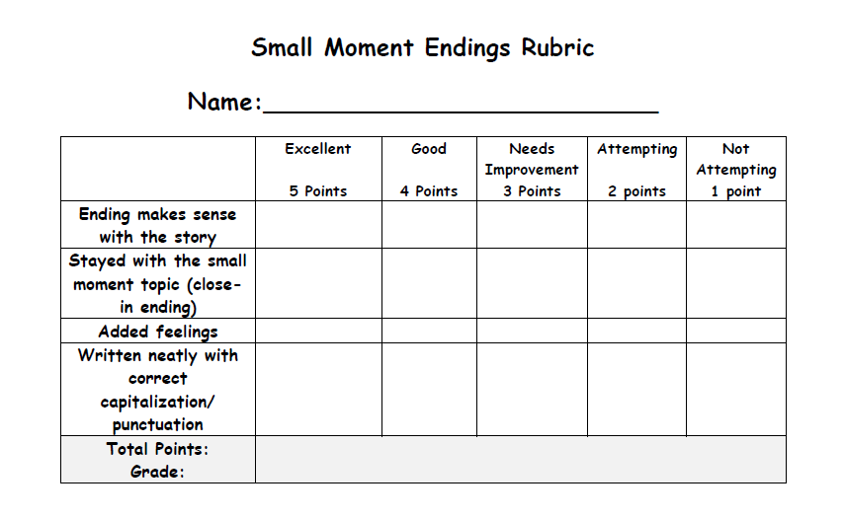

**Leads Rubric**

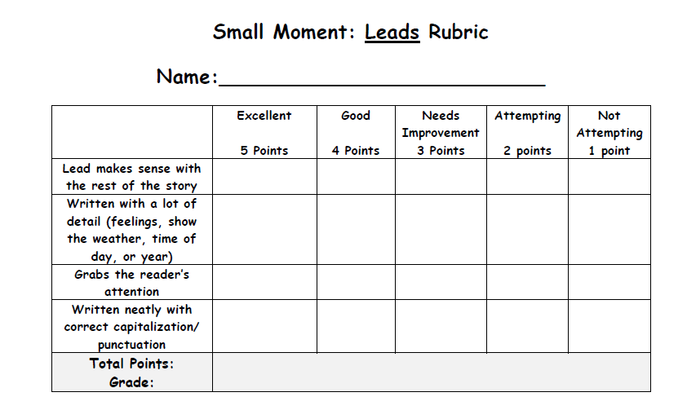

**Listening and Speaking Rubric**

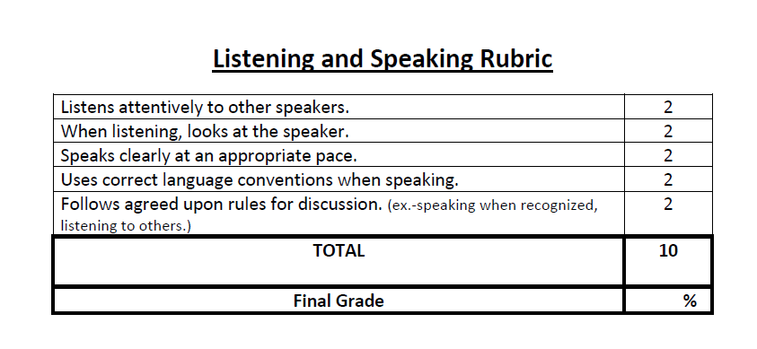

**Research Project Rubric**

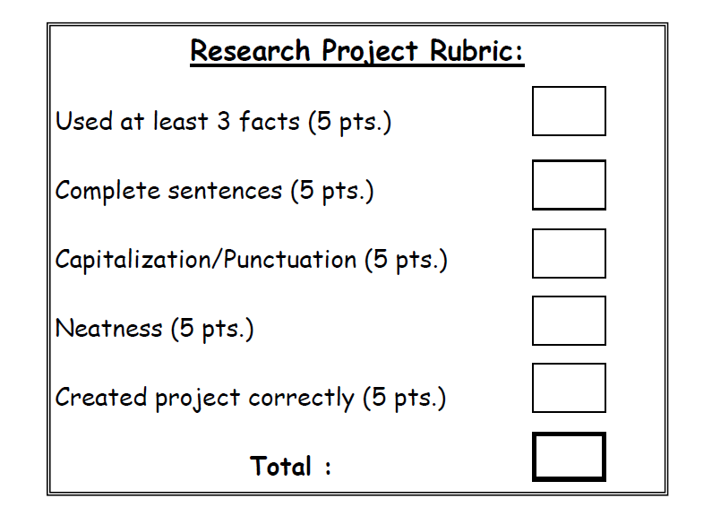

**KNWS Chat**

|  |  |  |  |
| --- | --- | --- | --- |
| **K**  What do I KNOW from the information stated in this problem? | **N**  What information do I NOT need in order to solve this problem? | **W**  WHAT exactly does this problem ask me to find? | **S**  What STRATEGY or operation will I use to solve this problem? |
|  |  |  |  |

**KWL Chat**

|  |  |  |
| --- | --- | --- |
| **What I KNOW** | **What I WANT to Know** | **What I LEARNED** |
|  |  |  |

**Fist to Five**

This formative assessment technique quickly allows the teacher to gauge the understanding of the learners in his/her classroom. After presenting a lesson, or part of a lesson, the teacher asks students to use their hand to signal their depth of understanding. A fist means, “I don’t understand any of it,” while all five fingers out means, “I understand it completely.” Students can signal by raising 1, 2, 3, or 4 fingers also. The teacher can readjust the next lesson or section of the lesson as needed based on student response. To hold students more accountable for their “truthfulness” the teacher can call on someone who signaled a 5 to explain the concept to the class, or partner students who understand (5) with those who don’t (0) and let them teach each other for a few minutes.

 

**Colored Cups**

This formative assessment technique quickly allows the teacher to gauge the understanding of the learners in his/her classroom. The teacher gives each student 3 cups; one red, one yellow and one green. As students work independently, they display the appropriate color of cup to indicate their understanding of the concept. A green cup means “I am working OK and encountering no problems.” A yellow cup means “I still have some questions because I can’t do some of the work.” A red cup means “I am lost and I don’t know how to proceed.” The teacher can work individually with students displaying the red cups, or bring them together for small group instruction. The same process can be used for the yellow cups, or a green cup could be paired with a yellow cup for peer tutoring. This same process can be used with colored cards if cups are not available.

Red

Green

Yellow

**Debate Circles**

**Kinesthetic Assessment**

This formative assessment can be used to activate student thinking and uncover their understandings and misconceptions. Students form a circle in the classroom or another large area. The teacher makes a statement, like, “Which is more important: Individual Rights or the Common Good?” Students who think Individual Rights are more important move to the center of the circle. Students left on the outside, those who think the Common Good is more important, form another circle and both groups formulate their position on the topic. The teacher listens to the discussion and assesses student understanding. After the students have had time to formulate their arguments, they form two lines facing one another and students take turns expressing their ideas on the statement.

C:\Documents and Settings\dwhite\Local Settings\Temporary Internet Files\Content.IE5\MNUXOBGF\MC900056992[1].wmf